

Practices for Secure Software Report

Table of Contents
Document Revision History 3
Client 3
Instructions 3
Developer 4
1. Algorithm Cipher 4
2. Certificate Generation 4
3. Deploy Cipher 4
4. Secure Communications 4
5. Secondary Testing 4
6. Functional Testing 4
7. Summary 4
8. Industry Standard Best Practices 4

Document Revision History

Version | Date | Author | Comments
1.0 | [Date] | [Your Name]

Client



Instructions

Submit this completed practices for secure software report. Replace the bracketed text with the relevant information. You must document your process for writing secure communications and refactoring code that complies with software security testing protocols.

- Respond to the steps outlined below and include your findings.
- Respond using your own words. You may also choose to include images or supporting materials. If you include them, make certain to insert them in all the relevant locations in the document.
- Refer to the Project Two Guidelines and Rubric for more detailed instructions about each section of the template.

Developer
Steven Markel

Algorithm Cipher

I would recommend a SHA-256 encryption algorithm cypher for Artemis Financial in this case. SHA-256 is part of the SHA-2 family of hash functions that were standardized by the National Institute of Standards and Technology (Computer Security Division, 2017). SHA-256 is a one-way function that takes input of any size and produces a 256-bit string, usually shown as a 64-character hex string. It is collision-resistant, meaning it is computationally infeasible to find two different inputs that produce the same hash output (What Is Strong and Weak Collision Resistance in Cryptography?, 13:10:00+00:00). SHA-256 is widely used in the fintech world and is the industry standard for secure file verification, digital signatures, and blockchain applications(A Deep Dive into Cryptographic Random Number Generation, 2024) (Gitlan, 2023).

For even stronger protection we can combine the SHA-256 with a secret key in an HMAC. This not only ensures that the data hasn’t been altered but also validates the checksum could only have been generated by someone with the secret key.

Encryption relies heavily on randomness to ensure unpredictability and security. Random numbers are used to generate encryption keys, provide unpredictability, and provide password security (A Deep Dive into Cryptographic Random Number Generation, 2024). In Java, the SecureRandom class is designed specifically for cryptographic use, producing values that are resistant to statistical analysis and guessing.

In this use, we are only using this cipher as symmetric encryption, meaning the same key is used for both encrypting and decrypting the data (Iron-Clad Java, n.d.). In symmetric encryption, the key must remain a secret and secure. We could add more protection by wrapping the SHA-256 key in an asymmetric key, or a public key. From our textbook, “Public key cryptography uses two different keys. One key, the private key, is kept secret and is known only to the sender. It is used to sign the data. The other key can be made public and can be known by anyone—hence the name, public key cryptography. This public key is used to validate the signature.” (Iron-Clad Java, n.d.). This hybrid approach of wrapping the AEs keys in asymmetric keys would allow for safe key exchanged by not compromising too much speed.

Encryption has evolved significantly over the past decades. Early methods such as substitution ciphers and the Data Encryption Standard (DES) provided basic protection but were eventually broken as computing power grew. The introduction of public-key cryptography in the 1970s revolutionized secure communications by letting people exchange information without pre-shared secrets. Around the same time, hash functions like MD5 and SHA-1 became popular for integrity checks, but both were later compromised by collision attacks, demonstrating the need for stronger algorithms (The History of Cryptography | IBM, 2024). Today, industry standards emphasize robust, efficient, and well‑tested algorithms (Computer Security Division, 2016). AES, adopted in 2001, remains the global standard for symmetric encryption, offering 128-, 192-, and 256-bit key sizes and widely used in TLS, VPNs, and financial systems. For integrity, SHA-2 (including SHA-256) is the most common hash function, while SHA-3 provides a backup standard (Technology, 2015).

Certificate Generation
Insert a screenshot below of the CER file.

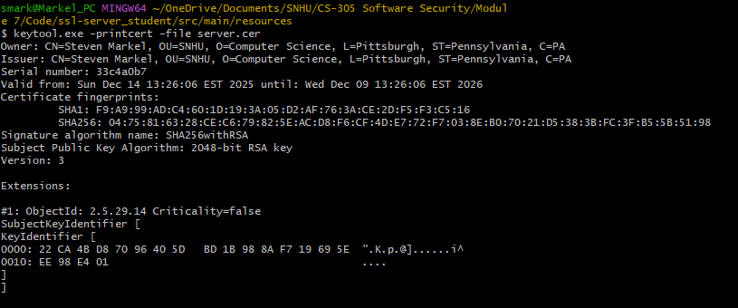

Deploy Cipher
Insert a screenshot below of the checksum verification.

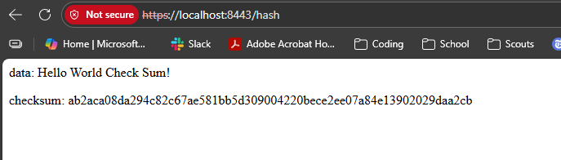

Secure Communications
Insert a screenshot below of the web browser that shows a secure webpage.

Secondary Testing
Insert screenshots below of the refactored code executed without errors and the dependency-check report.

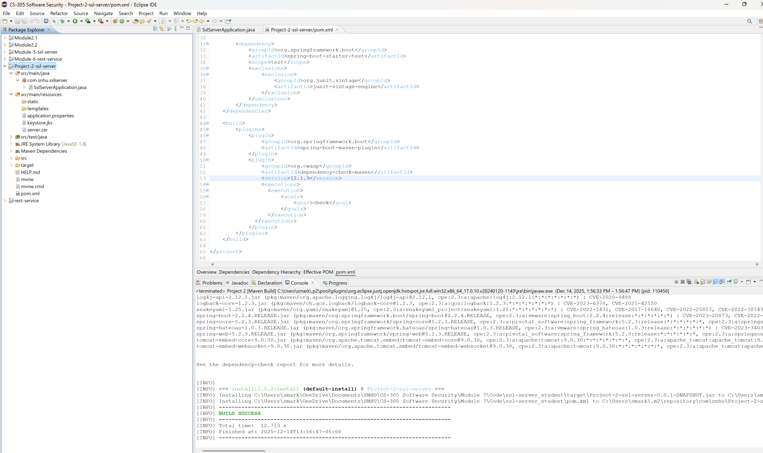
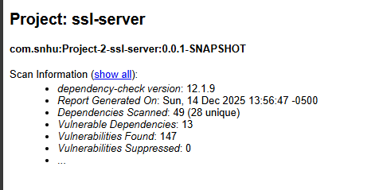

Functional Testing
Insert a screenshot below of the refactored code executed without errors.

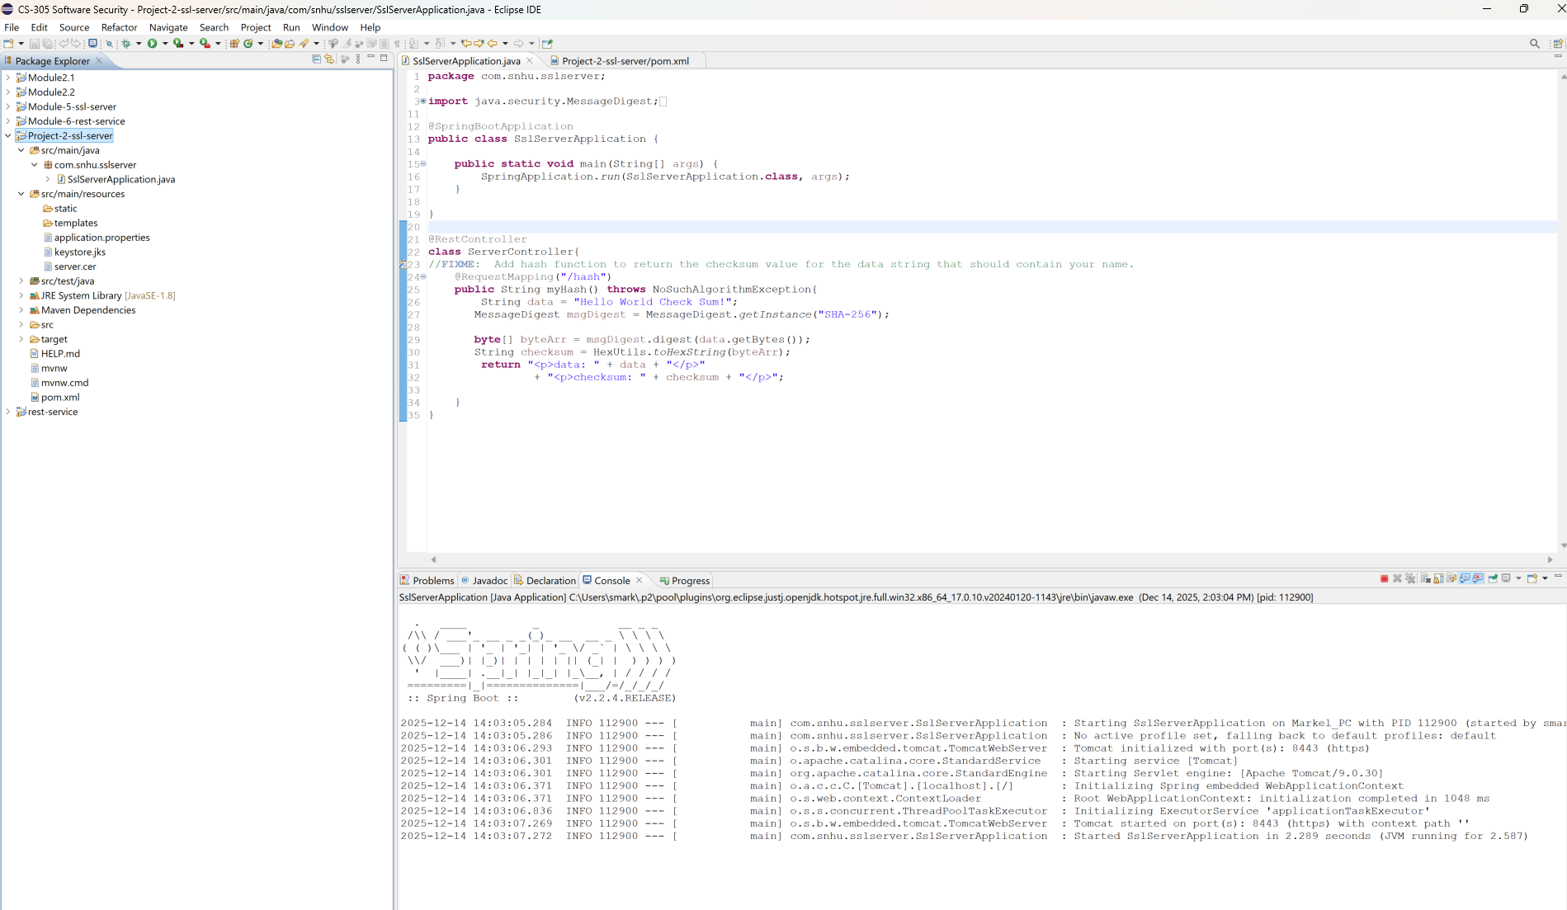

Summary

Before refactoring, the original application lacked the ability to run in a secure mode as well as a way for verifying data integrity. I added properties to the application.properties to insure that the application runs on HTTPS and a SHA-256 checksum function was added to the ServerController.

Industry Standard Best Practices

Industry standard best practices were applied throughout the refactoring to maintain and enhance the application’s security posture. Secure coding practices included avoiding deprecated algorithms (MD5, SHA‑1), using strong cryptographic primitives (SHA‑256, TLS 1.3), and explicitly handling character encoding to prevent ambiguity. Key management was implemented through Java’s Keytool and keystore, aligning with NIST recommendations for certificate handling. Static analysis with dependency‑check ensured that third‑party libraries did not introduce known vulnerabilities, and functional testing confirmed that the refactored code executed cleanly.

REFERENCES

A Deep Dive into Cryptographic Random Number Generation: From OpenSSL to Entropy. (2024, October 12). DEV Community. https://dev.to/mochafreddo/a-deep-dive-into-cryptographic-random-number-generation-from-openssl-to-entropy-16e6
Computer Security Division, I. T. L. (2016, December 29). Cryptographic Standards and Guidelines | CSRC | CSRC. CSRC | NIST. https://csrc.nist.gov/Projects/cryptographic-standards-and-guidelines
Computer Security Division, I. T. L. (2017, January 4). Hash Functions | CSRC | CSRC. CSRC | NIST. https://csrc.nist.gov/projects/hash-functions
Gitlan, D. (2023, April 26). What Is the SHA-256 Algorithm & How It Works. SSL Dragon. https://www.ssldragon.com/blog/sha-256-algorithm/
Iron-Clad Java: Building Secure Web Applications. (n.d.). Retrieved November 24, 2025, from https://learning.oreilly.com/library/view/iron-clad-java/9780071835886/ch06.html
Technology, N. I. of S. and. (2015). Secure Hash Standard (SHS) (No. Federal Information Processing Standard (FIPS) 180-4). U.S. Department of Commerce. https://doi.org/10.6028/NIST.FIPS.180-4
The History of Cryptography | IBM. (2024, January 5). https://www.ibm.com/think/topics/cryptography-history
What is Strong and Weak Collision Resistance in Cryptography? (13:10:00+00:00). GeeksforGeeks. https://www.geeksforgeeks.org/computer-networks/what-is-strong-and-weak-collision-resistance-in-cryptography/

